The Dangerous Dogs Act

Section 1 – Banned Breeds (UK)

These dogs listed below are banned in the UK. It is an offense to;
- own one of these dogs without it being exempted on the Index of Exempted Dogs
- breed, sell or rehome them
- have one of these breeds in public off lead or without a muzzle
- allow them to stray or to abandon them
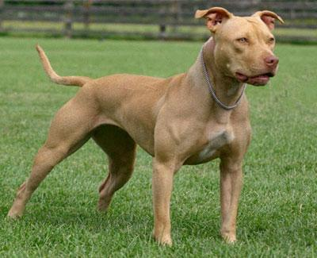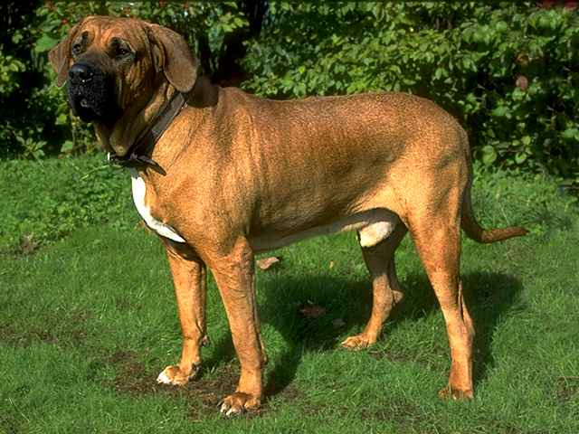
Figure 1- THE AMERICAN PITBULL TERRIER Figure 2 - THE FILA BRASILEIRO
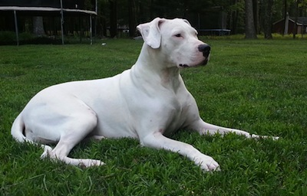
Figure 3 - THE JAPANESE TOSA Figure 4 - THE DOGO ARGENTINO
The maximum penalty for having a dog on the list and/or committing one of the other offences including breeding etc is a prison term of up to 6 months, although this is seldom carried out without other factors being taken into account, ie threatening behavior using the dog, dog fighting etc.

If you have a banned dog
If you have a banned dog, the police or local council dog warden can take it away and keep it, even if:
- it isn’t acting dangerously
- there hasn’t been a complaint
The police may need permission from a court to do this.
If your dog is in:
- a public place, the police don’t need a warrant
- a private place, the police must get a warrant
- a private place and the police have a warrant for something else (like a drugs search), they can seize your dog
A police or council dog expert will judge what type of dog you have and whether it is (or could be) a danger to the public. Your dog will then either be:
- released
- kept in kennels while the police (or council) apply to a court
You can give up ownership of your dog but you can’t be forced to. If you do, your dog could be destroyed without you even going to court.

Going to court
It’s your responsibility to prove your dog is not a banned type. If you prove this, the court will order the dog to be returned to you. If you can’t prove it (or you plead guilty), you’ll be convicted of a crime.
The maximum penalty for having a banned dog against the law is a £5,000 fine or 6 months in prison (or both). Your dog will also be destroyed.

Index of Exempted Dogs (IED)
If your dog is banned but the court thinks it’s not a danger to the public, it may put it on the IED and let you keep it. You’ll be given a Certificate of Exemption. This is valid for the life of the dog.
Your dog must be neutered, microchipped, kept on a lead and muzzled at all times when in public, and kept in a secure place so it can’t escape.

The Dangerous Dogs Act

Section 3 – Dogs Dangerously out of Control
It’s now against the law to let a dog be dangerously out of control anywhere. This change came into force in May 2014 and applies to ALL owners, ALL breeds of dogs and ALL locations, including public spaces (parks, beaches etc), private places (your garden, your friend’s garden) or in your own home.

Your dog is seen to be ‘out of control’ if it…
- injures a person
- makes that person afraid that they are liable to be injured.

This could be as little as a dog jumping up to greet someone or becoming overexcited and barking, so all dog owners must be aware and take appropriate precautions.
For example,
- keeping the dog away from post persons, parcel delivery people, meter readers etc
- getting a mailbox outside the property or a mail cage if the dog can access the letterbox
- having a fully secure boundary from which the dog cannot escape
- allowing a safe passage for people to get to your front door without your dog being able to ‘greet’ them
- training your dog to be calm around new people, or limiting contact, especially with nervous visitors
- telling neighbours that you have a dog and asking young people not to come around, without asking, to collect balls etc

Householder Clause
The one exemption to this is the Householder Clause. If someone illegally enters your house (in court referred to as your main dwelling) and your dog defends the home against them, the owner will not be held responsible.
However if an intruder/burglar comes into your outbuildings, garden, garage, sheds etc and the dog attacks them, this is not permitted and you can still be prosecuted.
It is all about the location, so if you hear noises outside do not let your dog out to investigate.

Penalties
The maximum prison sentences for crimes involving ‘out of control dogs’ have been increased to a maximum of:
- 14 years for a fatal dog attack
- 5 years for injury
- 3 years for an attack on any assistance dog

Please ensure that dogs are kept safe by sharing this information with family and friends and other dog owners. Ignorance is no excuse in a court room, so be prepared.

As a dog owner what laws do I need to be aware of when I am taking my dog out for a walk?

Walking your pet dog and the law
There are a number of laws that a dog walker should be aware of. This article provides guidance on some of the main laws that a dog walker should bear in mind.

Environmental matters
The Clean Neighbourhoods and Environment Act 2005 gives local authorities and similar authorities the power to make “Dog Control Orders” in relation to public land. A Dog Control Order may relate to the fouling of land by dogs and the removal of dog faeces; the keeping of dogs on leads; the exclusion of dogs from land and the number of dogs which a person may take on to any land. Failure to comply with a Dog Control Order is a criminal offence punishable by a fine.
The Act gives local authorities and similar authorities the power to issue a fixed penalty notice to any person who is believed to have committed an offence under a Dog Control Order. If is an offence, punishable by fine, for a person to fail to supply his name or address or give a false or inaccurate name or address to a person authorised to issue a fixed penalty notice.

Leads, collars and muzzles
Under the Road Traffic Act 1988 it is a criminal offence to cause or permit a dog to be on a road, which has been designated by a local authority as a road to which the Act relates, without the dog being held on a lead. There are exceptions for dogs proved to be kept for driving or tending sheep or cattle in the course of a trade or business and for dogs proved to have been at the material time in use under proper control for sporting purposes.
The Control of Dogs Order 1992 requires every dog, (apart from a few exceptions which are set out in the order), while in a highway or public place to wear a collar with the name and address of the owner inscribed on the collar or on a plate or badge attached to it. The exceptions relate to packs of hounds, dogs being used for sporting purposes, dogs being used for the capture or destruction of vermin, dogs being used for the driving or tending of cattle or sheep, dogs being used on official duties by a member of the Armed Forces or Customs and Excise or a police force, dogs being used in emergency rescue work and dogs registered with the Guide Dogs for the Blind Association.
It is a criminal offence, under the Animal Health Act 1981, where an owner or person in charge of a dog fails, without lawful authority of excuse (which he must prove) to comply with the requirements relating to collars as set out in the Control of Dogs Order 1992. The Control of Dogs Order 1992 also allows for any such dog to be seized and treated as a stray dog under the Dogs Act 1906 or the Environmental Protection Act 1990. Enforcement of any such offence is carried out by the local authorities.
Under the Dangerous Dogs Act 1991 it is a criminal offence to allow a pit bull terrier, Japanese tosa or any dog designated by the Secretary of State as being a dog bred for fighting, to be in a public place without being muzzled and kept on a lead by someone who is 16 years old or above. Where an offence is committed the offender may be imprisoned and/or fined. The Court may also order the destruction of the dog and may order the offender to be disqualified from having custody of a dog, for such period as the Court thinks fit.

Safety to others
If a dog is dangerously out of control in a public place the owner and any person in charge of the dog at the time commits a criminal offence, punishable by imprisonment and/or a fine under the Dangerous Dogs Act 1991. If the dog injures a person while so out of control an aggravated offence is committed. If at the time the dog was under the control of a person other than the owner, the owner will have a Defence if he can show that he reasonably believed the person was a fit and proper person to be in charge of the dog. Where an offence is committed the Court may order the destruction of the dog and may order the offender to be disqualified from having custody of a dog, for such period as the Court thinks fit.

Livestock
Where a dog causes damage by killing or injuring livestock the keeper of the dog is liable for such damage under the Animals Act 1971.
The Animals Act 1971 also provides a Defence to any civil proceedings brought against a person for killing or causing injury to a dog where the Defendant acted for the protection of livestock and was a person entitled to act for the protection of that livestock and reported the killing or injury to the officer in charge of a police station within 48 hours.

Under the Dogs (Protection of Livestock) Act 1953 where a dog worries livestock on any agricultural land, the owner of the dog and any person who is in charge of the dog at the time commits a criminal offence, punishable by a fine.

Under the DDA, young persons under the age of 16 are NOT classed as legally responsible for dogs when out walking.
If your child allows your dog to cause an accident/damage/injury, you as the adult owner will be liable for ALL damages.
Is it really worth it?

Walk as a family and safeguard your dog, your child and your bank account

